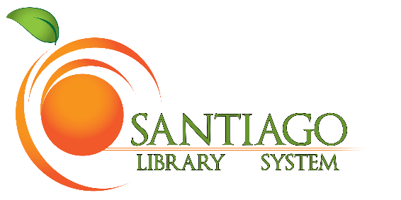

Santiago Library System
Tech Services & Technology Committee Meeting Agenda
October 29, 2024, at 1:00 p.m.
Meeting Taking place in the Osborne Auditorium, Fullerton Public Library
353 W Commonwealth Ave, Fullerton, CA 92832

Call to Order
- Call to Order
- Roll Call
- Adoption of Agenda
- Oral Communications / Public Comments
Consent Calendar
- Approve minutes of the April 23, 2024, Santiago Library System Tech Services & Technology Committee Meeting

Regular Business
- Ordering Vox Books from Baker & Taylor (as requested by Yorba Linda)
- Vendors for Print Release/PC Reservation (as requested by Fullerton)
- Round Table Discussion

Adjournment
- Agenda Preparation for next Meeting (January 2025), Location TBD
- Adjournment

